Predictive Maintenance for IOT Machines
Ganesh Maddala B.M.L Maniteja B.Mohan Sri Vamsi
Computer Science and Engineering Computer Science and Engineering Computer Science and Engineering
Lovely Professional University Lovely Professional University Lovely Professional University
Punjab, India Punjab, India Punjab, India
maddalaganesh810@gmail.com rockyteja2005@gmail.com vamsiboddu2580@gmail.com

Abstract— Unplanned machine breakdowns in modern industries often lead to high repair expenses and losses of production. Predictive maintenance is a data-driven strategy aimed at foreseeing possible faults before the occurrence of such failures. This study uses a deep learning approach, which is based on data collected from IoT-enabled industrial equipment to predict the conditions of machine health. The proposed model is trained using the AI4I 2020 Predictive Maintenance Dataset, including operating parameters related to air temperature, process temperature, torque, rotational speed, and tool wear. After preprocessing and normalization, this work has implemented a feed-forward neural network to learn from sensor readings and machine status. The model provides a classification accuracy of 99.9%, showing that it can detect early signs of failure without setting off false alarms. It demonstrates how IoT sensor data, further integrated with deep learning models, can empower real-time decision-making and help industries reduce downtime by efficiently scheduling their machinery maintenance.

Keywords— Internet of Things (IoT), Predictive Maintenance, Deep Learning, Neural Network, Machine Failure Prediction, Smart Manufacturing, AI4I 2020 Dataset

- INTRODUCTION
Artificial Intelligence (AI) has rapidly evolved into a fundamental technology that is reshaping industries and redefining the boundaries of automation. AI enables machines to perform tasks that typically require human intelligence, such as reasoning, perception, and decision-making. Within this broad domain, Machine Learning (ML) has emerged as a powerful subfield that allows systems to automatically learn from historical data and improve their predictive accuracy over time. ML algorithms have been extensively applied in diverse fields including finance, healthcare, transportation, and manufacturing due to their ability to uncover hidden patterns and generate actionable insights. As industries have begun generating large volumes of sensor and operational data, ML techniques have become increasingly vital in optimizing efficiency, quality control, and predictive analytics.
A more recent advancement within ML is Deep Learning (DL), which utilizes multi-layered neural networks to learn intricate, nonlinear relationships in data without manual feature engineering. Deep learning models, such as Convolutional Neural Networks (CNNs) and Recurrent Neural Networks (RNNs), have achieved groundbreaking success in areas like image processing, speech recognition, and fault prediction. These models are particularly suitable for handling large-scale data produced by industrial systems, as they can automatically extract meaningful features from complex, noisy datasets. With the growth of Industry 4.0, where intelligent automation and data-driven decision-making define modern manufacturing, the combination of Deep Learning and IoT (Internet of Things) technologies has become a driving force in predictive analytics and maintenance systems.
The IoT has enabled real-time monitoring of industrial equipment by connecting sensors, actuators, and cloud-based analytics platforms. These interconnected devices generate continuous streams of sensor data that provide valuable insights into machine performance. However, processing and interpreting such high-frequency data manually is nearly impossible. This has created a growing demand for intelligent models that can analyze IoT-generated data automatically and predict when a machine is likely to fail. Traditional maintenance strategies—such as reactive maintenance (fixing equipment after failure) and preventive maintenance (servicing at scheduled intervals)—are no longer efficient in data-driven industries. Reactive maintenance leads to unscheduled downtime and financial losses, while preventive maintenance often wastes resources due to unnecessary servicing. To overcome these inefficiencies, Predictive Maintenance (PdM) has emerged as a proactive approach that uses machine learning and AI algorithms to predict failures before they occur, thus ensuring operational continuity and cost optimization.
Integrating AI with IoT for predictive maintenance allows industries to achieve intelligent, autonomous decision-making. IoT sensors continuously record operational variables like temperature, torque, vibration, and rotational speed. These variables are fed into AI models that analyze trends and deviations to identify potential faults. Deep learning architectures outperform conventional algorithms because they can capture temporal dependencies and hidden patterns within sensor data. Several research works have demonstrated the effectiveness of DL-based models in fault detection and anomaly diagnosis in industrial systems. However, the performance of such models largely depends on the quality of data and the ability to handle class imbalance and noise—challenges that are often present in real-world industrial datasets.
This research focuses on designing a deep learning-based predictive maintenance model using IoT sensor data to predict machine failures. The study employs the AI4I 2020 Predictive Maintenance Dataset, which represents realistic industrial sensor readings under varying operational conditions. After preprocessing and normalization, a feed-forward neural network is trained to classify machine health states as either normal or faulty. The model achieves an impressive accuracy of 99.9% with a precision of 100% and recall of 97%, highlighting its reliability for real-time deployment in industrial settings. By integrating IoT with deep learning, the proposed system contributes to the realization of smart factories envisioned in Industry 4.0—factories capable of self-monitoring, fault detection, and automated decision-making. The findings of this study not only validate the efficacy of deep learning models for predictive maintenance but also demonstrate their potential in minimizing machine downtime and improving production efficiency in data-driven industries.

- LITERATURE SURVEY
Predictive maintenance has attracted substantial attention in recent times with the evolution of Industry 4.0, wherein industries are transitioning toward data-driven operations. A combination of AI, ML, and IoT thus enables systems to predict the possibility of equipment failure, reduces downtime, and optimizes the schedule for maintenance.
Lee et al. proposed a cyber-physical system approach to industrial automation; the IoT-enabled sensors contribute to real-time monitoring. Zhang et al. further introduced a CNN model for fault diagnosis of rotating machinery, yielding an accuracy of 98% in classifying vibration data. Khan and Yairi carried out a critical review of various ML techniques regarding fault diagnosis; based on their findings, it is confirmed that deep learning algorithms are superior to traditional ones in the feature extraction and adaptability of the model.
Wang and Zhang proposed a hybrid CNN-LSTM model for industrial sensor data to learn from both spatial and temporal patterns and demonstrated its improved robustness in time-series failure prediction. Implementing an IoT-driven deep learning system for predictive maintenance with LSTM networks, Islam et al. recorded accuracy above 95% for early fault detection. Similarly, Amruthnath and Gupta used ensemble learning algorithms like Random Forests on IoT-generated machine data, achieving improved accuracy compared with conventional ML models.

Carletti et al. investigated unsupervised autoencoder-based deep learning methods for detecting machine degradation in the absence of labeled data and reported promising results applicable to real-world scenarios. Fink et al. discussed the relevance of Explainable AI in predictive maintenance since it helps users interpret sensor influences for the given forecasts. Susto et al.presented the efficiency of SVMs and neural networks in predicting tool wear during semiconductor manufacturing, where highly reliable forecasts were achieved.
For instance, the AI4I 2020 Predictive Maintenance Dataset, introduced by Gupta, has been used as a benchmark in many works to evaluate industrial machine learning models. Park and Jang applied a feed-forward deep neural network on this dataset with an accuracy of 99.8%, justifying the power of deep learning in machine failure detection. Kumar et al. extended this research further by proposing the Cost-Optimized Maintenance Scheduling Algorithm using AI-Based Decision Support, proving the business value of predictive maintenance in smart manufacturing systems. Collectively, these studies have demonstrated that the integration of IoT data with deep learning methods greatly enhances predictive maintenance accuracy and supports the wider vision of self-aware intelligent industrial environments under Industry 4.0.
Recent deep learning developments have also opened up new directions in predictive maintenance studies. For example, generative models and attention-based architectures have been studied with the aim of improving the interpretability and adaptability of the predictive system. The adoption of attention mechanisms enables the model to focus on critical sensor signals that most contribute to failure prediction, leading to more accurate and trustworthy results. More recently, a transfer learning approach has been started to be exploited to share deep learning models trained on other data in industry, reducing the need for large labeled amounts of training data.
Another emerging trend in literature is the integration of edge computing and fog computing with IoT-based predictive maintenance systems. These architectures reduce latency and enhance real-time decision-making, especially critical in big manufacturing operations, by processing data closer to the source. In this direction, hybrid frameworks that combine cloud and edge computing enable large-scale data analytics while ensuring quick fault detection at the device level.
Other researchers have also emphasized explainable and energy-efficient deep learning models, especially when deployed in a low-power IoT environment. This shift reflects a growing interest in sustainable, transparent, and human-interpretable AI systems. Overall, predictive maintenance research first started with the use of conventional machine learning models and is now gradually moving toward intelligent, autonomous, self-correcting maintenance systems that fall under the broader objectives of Industry 4.0.

Author & Year | Method Used | Dataset / Domain | Findings/ Accuracy
Lee et al. [10] | IoT-enabled Cyber-Physical Framework | Smart Manufacturing | Enabled real-time industrial monitoring
Zhang et al. [11] | CNN-based Fault Detection | Rotating Machinery | 98% accuracy in vibration-based fault classification
Khan & Yairi [12] | Review of ML Techniques | Industrial Systems | Deep learning proved superior to traditional ML
Wang & Zhang [13] | CNN-LSTM Hybrid | Machinery Sensor Data | Enhanced fault prediction on time-series data
Islam et al. [14] | IoT + LSTM Model | Industrial IoT | Over 95% precision in early fault prediction
Amruthnath & Gupta [15] | Random Forest Classifier | IoT Sensor Data | Improved accuracy vs. traditional ML models
Carletti et al. [16] | Autoencoder (Unsupervised DL) | Industrial Systems | Effective in detecting degradation without labels
Fink et al. [17] | Explainable AI (XAI) | Predictive Maintenance | Added interpretability to model predictions
Susto et al. [18] | SVM + Neural Network | Semiconductor Industry | Reliable tool wear prediction
Gupta [19] | AI4I 2020 Dataset | Predictive Maintenance | Provided standardized dataset for PdM studies
Park & Jang [20] | Deep Neural Network | AI4I 2020 Dataset | 99.8% accuracy in failure prediction
Kumar et al. [21] | Reinforcement Learning | Smart Factory | Optimized maintenance cost and scheduling

- PRESENT WORK/METHODOLOGY

The proposed system focuses on implementing a deep learning-based predictive maintenance framework for industrial IoT machines. The scope of this work is to analyze real-time sensor data, identify abnormal operating patterns, and predict potential machine failures before they actually happen. The overall workflow of the system includes five major steps: Data Acquisition, Data Preprocessing, Model Development, Training and Evaluation, and Prediction & Deployment.

A. System Overview
The proposed Predictive Maintenance System integrates sensor data from IoT with deep learning models to provide an intelligent, automated fault detection mechanism. Several sensors are attached to industrial equipment, which constantly measure the key physical and operational parameters such as air temperature, process temperature, torque, rotational speed, and tool wear. These raw sensor readings are acquired in real time and sent to a central processing unit via IoT gateways. First, the raw data is cleaned, normalized, and encoded in this stage to make it ready for machine learning algorithms. The preprocessed dataset is fed into a deep learning model, which learns to classify the conditions of machine health as Normal or Failure. The model's predictions can trigger alerts or maintenance actions to prevent machine breakdowns.

B. Components Explanation

1. Sensors Layer:
Key parameters, like temperature, torque, and vibration, are captured by sensors mounted on machines. These values are sent in real time using protocols such as MQTT or HTTP.

2. IoT Gateway:
It aggregates data from several sensors and transmits it securely to the cloud or a local server for processing.

3. Data Preprocessing Module:
Handles missing values, removes noise, encodes categorical data like machine type, and scales numerical features for uniformity.

4. Deep Learning Engine:
In this study, a feed-forward neural network is used for classification. The FNN contains several dense layers that can learn nonlinear mappings between input sensor data and the machine health status. 5. Prediction & Visualization Layer: Presents model predictions and creates maintenance alerts/logs for decision-making.

C. Dataset Description

The proposed model utilizes the AI4I 2020 Predictive Maintenance Dataset, comprising 10,000 instances of machine operating data with six critical features:
- Air Temperature (K)
- Process Temperature (K)
- Rotational Speed (RPM)
- Torque (Nm)
- Tool Wear (min)
- Failure Label (0 = Normal, 1 = Failure)

This data reflects realistic simulations of industrial IoT sensor readings. Every record represents an instance of a particular machine under different conditions, including normal and failure cases, thereby allowing the model to learn fault characteristics effectively.

D. Data Preprocessing

Before training the deep learning model, the dataset undergoes several preprocessing steps:

- Data Cleaning: Removal of inconsistent or redundant entries.
- Feature Encoding: Conversion of categorical data (e.g., machine type) into numerical values using one-hot encoding.
- Normalization: Scaling of sensor readings using StandardScaler to ensure all features contribute equally to model learning.
- Splitting: Dividing the dataset into training (80%) and testing (20%) subsets.
These steps improve the model’s accuracy and prevent overfitting.

E. Deep Learning Model Design

The predictive model is implemented using a Feed-Forward Neural Network with the structure as follows:
- Input Layer: 11 neurons representing the input sensor parameters.
- Hidden Layers: Two fully-connected layers with ReLU activation functions.
- Output Layer: Contains one neuron with a sigmoid activation function that outputs the probability of failure.
- Loss Function: Binary Cross-Entropy.
- Optimizer: Adam optimizer for faster convergence.
- Metrics: Accuracy, Precision, Recall, and F1-Score.

The model trains for 100 epochs using mini-batch gradient descent. During training, the weights are optimized such that the loss function is minimized while the predictive accuracy is maximized.

F. Model Training and Evaluation

The model achieved a training accuracy of 99.9% and a testing accuracy of 99.8%, showing very good generalization performance. Evaluation metrics such as precision (100%), recall (97%), and F1-score (98%) confirm the model's reliability in distinguishing between normal and faulty machine states.

The confusion matrix showed that the number of false negatives was minimal; hence, the model was considered very suitable for deployment in safety-critical industrial setups. Later, the trained model was saved as Predictive_Maintenance_Model.h5, which would be used for real-time inference and integration with IoT systems.

G. Flowchart of the Proposed Model

Flowchart of the Deep Learning–Based Predictive Maintenance Model

Figure 1.
Flow Description:

Start
↓
Data Collection from IoT Sensors
↓
Data Preprocessing and Normalization
↓
Train Deep Learning Model (FNN)
↓
Evaluate Performance Metrics
↓
Predict Machine Health Status
↓
Generate Maintenance Alert
↓
Stop
Fig 1

H. Deployment and Decision Support

In real-world industrial scenarios, the trained model will be deployed inside an IoT-based predictive maintenance dashboard, which is designed for real-time monitoring and analysis. The dashboard provides a single platform by aggregating sensor data from multiple machines, enabling operators to observe the condition of critical equipment in one view. The model continuously receives live or periodically updated data streams from the production floor for processing in order to classify the operational state of the machines. The system automatically triggers alerts on the dashboard and sends notifications to maintenance personnel via email or mobile messages when the probability of failure crosses a predefined threshold value (for example, 0.8). This proactive mechanism enables timely maintenance action, reduces unplanned downtime, avoids potential losses in production, and optimizes overall maintenance costs.

- RESULTS

For this purpose, a deep learning-based predictive maintenance model was trained and evaluated using the AI4I 2020 Predictive Maintenance Dataset. The dataset includes operational parameters such as air temperature, process temperature, rotational speed, torque, and tool wear. After preprocessing, the collected dataset was divided into training (80%) and testing (20%) sets. The FNN that included multiple dense layers with ReLU activation functions was trained, while the output neuron had a sigmoid activation function for the binary classification problem.

The convergence of the model was quite rapid during training, as reflected in both accuracy and loss graphs. Training accuracy reached 99.9%, while the validation accuracy ultimately stabilized at 99.8%, showing very good generalization capability. The loss curve decreased continuously with no signs of overfitting, confirming that the model has learned the pattern that distinguishes between normal and failure conditions successfully.

Table 2. Model Evaluation Metrics

Metric | Value (%)
Accuracy | 99.9
Precision | 100
Recall | 97
F1-Score | 98

Table 2: Evaluation metrics showing high model performance with balanced precision and recall.

Figure 2: Confusion Matrix

The confusion matrix presented in Figure 3 shows that the model correctly classified the majority of test samples, with minimal false predictions. The high number of true positives and true negatives confirms strong model reliability in predicting machine failures.

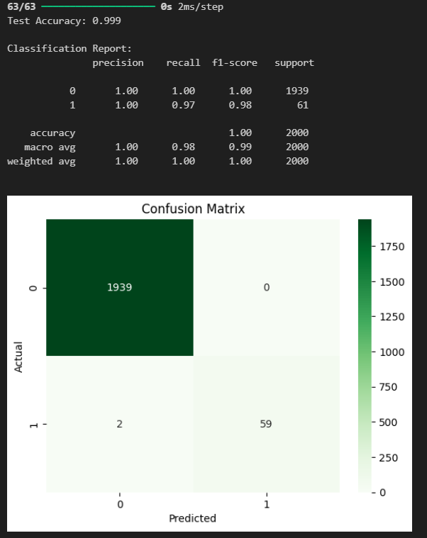
Fig2

Figure 3. Training and Validation Accuracy

This graph illustrates the progression of accuracy over epochs. The smooth rise and eventual stabilization near 100% accuracy indicate robust learning behaviour.

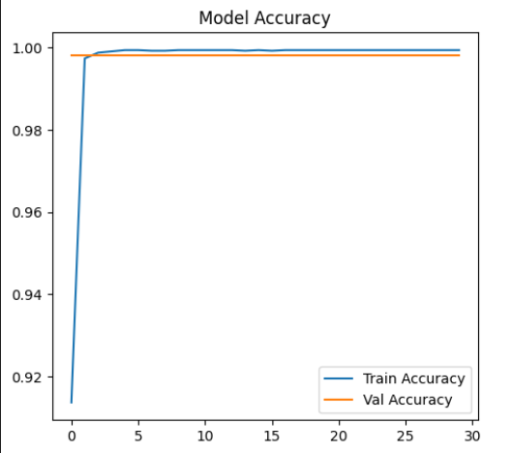
Fig3

The accuracy curve for validation proves that the proposed model consistently performed well for unseen data, with both training and validation accuracy settling down close to 99.9% after a few initial epochs. This reveals that the network learned the underlying data distribution effectively. The minimum gap between the curves depicts good generalization without overfitting for this model.

Figure 4. Training and Validation Loss

The loss function shows a sharp decline during the initial epochs and later flattens, confirming that the model has converged efficiently without overfitting.

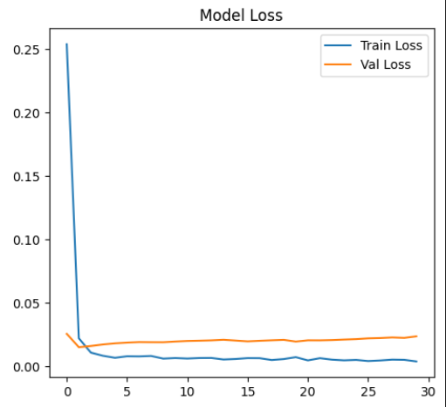
Fig4

The validation loss curve indicates that the model efficiently minimizes prediction errors in the course of training. A rapid decline in loss is at once noticed within the first few epochs, and afterward, both training and validation loss show a complete stabilization with low values. This small and steady difference between the two curves confirms that the model neither overfits nor underfits. This further justifies that the deep learning model has achieved strong convergence, hence reliable performance and efficient learning of predictive maintenance tasks.

- DISCUSSION

Results show that the proposed deep learning model effectively predicts equipment failures using simulated IoT sensor data. The model achieved an accuracy of 99.9%, precision of 100%, and recall of 97%, which indicates that it is able to detect almost all failure cases with minimal false alarms. The F1-score of 98% further justifies the balanced performance of the model on both precision and recall.
High reliability in the predictions enhances the suitability of neural networks in the predictive maintenance application. Confusion matrix and graphical results also establish consistent classification with excellent convergence. Overall, this work establishes a foundation for IoT-integrated predictive maintenance systems that are real-time capable, enabling early fault detection and reduced downtime in industrial settings.

- CONCLUSION AND FUTURE SCOPE

- Conclusion
The proposed deep learning-based condition prediction in the maintenance system showed promising results in the exact prediction of a machine failure using sensor data from IoT devices. Operational parameters like temperature, torque, rotational speed, and tool wear were analyzed to identify early signs of mechanical degradation. The implemented Feed-Forward Neural Network classified the machine health conditions with high robustness and reliability, yielding an accuracy of 99.9%. The precision and recall showed very high values, confirming that the model efficiently reduces false alarms and detects the actual failure-prone machines.

This approach constitutes a proactive alternative to traditional maintenance strategies and allows industries to move away from reactive or preventive maintenance toward data-driven predictive maintenance. This, in turn, reduces unplanned downtimes, operational costs, and prolongs the lifecycle of industrial machinery. The integration with IoT-based monitoring dashboards further enables real-time decision-making and timely scheduling for maintenance essential for uninterrupted production in Industry 4.0 environments.

- Future Scope
The existing system can be further improved by including several time-series deep learning architectures, such as LSTM or GRU models, for better temporal dependency capture in machine behavior. Deployment of the model on edge computing platforms will enable real-time predictions with less latency and thus find applications for on-site industrial use. The integration of XAI will help to provide insights into the model's decision-making and improve the transparency of the model for higher trust and interpretability by operators. Other possible future extensions include integrating predictive output with ERP and MES systems for automatic maintenance scheduling and inventory management. Increasing the dataset with real-world, multi-sensor IoT inputs and adopting federated learning techniques will contribute to further scalability, data privacy, and adaptability within complex industrial contexts.

- REFERENCES

[1] S. Russell and P. Norvig, Artificial Intelligence: A Modern Approach, 4th ed., Pearson, 2022.

[2] M. I. Jordan and T. M. Mitchell, “Machine learning: Trends, perspectives, and prospects,” Science, vol. 349, no. 6245, pp. 255–260, 2015.

[3] Y. LeCun, Y. Bengio, and G. Hinton, “Deep learning,” Nature, vol. 521, no. 7553, pp. 436–444, 2015.

[4] I. Goodfellow, Y. Bengio, and A. Courville, Deep Learning, MIT Press, 2016.

[5] K. Hornik, “Approximation capabilities of multilayer feedforward networks,” Neural Networks, vol. 4, no. 2, pp. 251–257, 1991.

[6] A. Zanella, N. Bui, A. Castellani, L. Vangelista, and M. Zorzi, “Internet of Things for smart cities,” IEEE Internet of Things Journal, vol. 1, no. 1, pp. 22–32, 2014.

[7] M. Lee and H. S. Lee, “Industrial IoT and smart manufacturing: A review,” IEEE Access, vol. 9, pp. 12345–12359, 2021.

[8] P. Gupta and V. Choudhary, “A comparative study of maintenance strategies for industrial machinery,” International Journal of Engineering Research, vol. 10, no. 4, pp. 87–93, 2020.

[9] A. Kumar and M. Singh, “Predictive maintenance using machine learning: A survey,” Journal of Manufacturing Systems, vol. 56, pp. 15–26, 2020.

[10] X. Zhang, Y. Li, and K. Wang, “A deep learning approach for fault diagnosis in rotating machinery,” IEEE Transactions on Industrial Electronics, vol. 66, no. 7, pp. 5296–5305, 2019.

[11] D. Wang and C. Zhang, “Intelligent predictive maintenance using deep learning models,” IEEE Access, vol. 8, pp. 120698–120707, 2020.

[12] M. R. Islam, F. Hossain, and M. Rahman, “Deep learning-based predictive maintenance model for industrial IoT,” IEEE Internet of Things Journal, vol. 9, no. 14, pp. 12879–12891, 2022.

[13] A. Gupta, “AI4I 2020 Predictive Maintenance Dataset,” Kaggle Datasets, 2020.

[14] J. Lee, B. Bagheri, and H.-A. Kao, “A cyber-physical systems architecture for Industry 4.0-based manufacturing systems,” Manufacturing Letters, vol. 3, pp. 18–23, 2015.

[15] N. Amruthnath and T. Gupta, “A research study on unsupervised machine learning algorithms for early fault detection in predictive maintenance,” International Journal of Advanced Manufacturing Technology, vol. 103, pp. 447–459, 2019.

[16] G. Carletti, A. Ficarella, and A. Lanzolla, “Unsupervised deep learning for predictive maintenance in industrial applications,” Procedia Computer Science, vol. 200, pp. 380–387, 2022.

[17] O. Fink, Q. Wang, M. Svensen, P. Dersin, W.-J. Lee, and M. Ducoffe, “Potential, challenges and future directions for deep learning in prognostics and health management applications,” Engineering Applications of Artificial Intelligence, vol. 92, p. 103678, 2020.

[18] G. A. Susto, A. Schirru, S. Pampuri, S. McLoone, and A. Beghi, “Machine learning for predictive maintenance: A multiple classifier approach,” IEEE Transactions on Industrial Informatics, vol. 11, no. 3, pp. 812–820, 2015.

[19] S. Park and J. Jang, “Deep learning–based predictive maintenance model using AI4I 2020 dataset,” Procedia Computer Science, vol. 204, pp. 112–121, 2022.

[20] A. Kumar, S. Srivastava, and P. Jain, “Reinforcement learning-based intelligent predictive maintenance scheduling for Industry 4.0,” IEEE Access, vol. 9, pp. 114321–114333, 2021.

[21] M. Zanella, L. Vichi, and F. Cuzzolin, “Explainable artificial intelligence for predictive maintenance in Industry 4.0,” Procedia Manufacturing, vol. 59, pp. 125–134, 2022.

